Project Title: Smart Fashion Recommender Application Project Design Phase-I - Solution Fit Template Team ID:PNT2022TMID43844

. TRIGGERS

3

TR

.when they don”t get a required product

1

.if the application does not work efficiently

2

.If they don’t get a order in a correct time

3

.tf they get a incorrect or less quality product

4

. YOUR SOLUTION

10

SL

.Ask, Ask and Ask.

1

.Identify the Problem.

2

3

.Formulate Solutions.

4

.Deliver the Solution.

.Follow up with Customers.

5

8.

CHANNELS of BEHAVIOR

CH

8.1

ONLINE

1

.They have to report a issue in their application

.Make a complaint

2

3

.Return policies

8.2

OFFLINE

Go ask the seller about their problems and

get solve them.

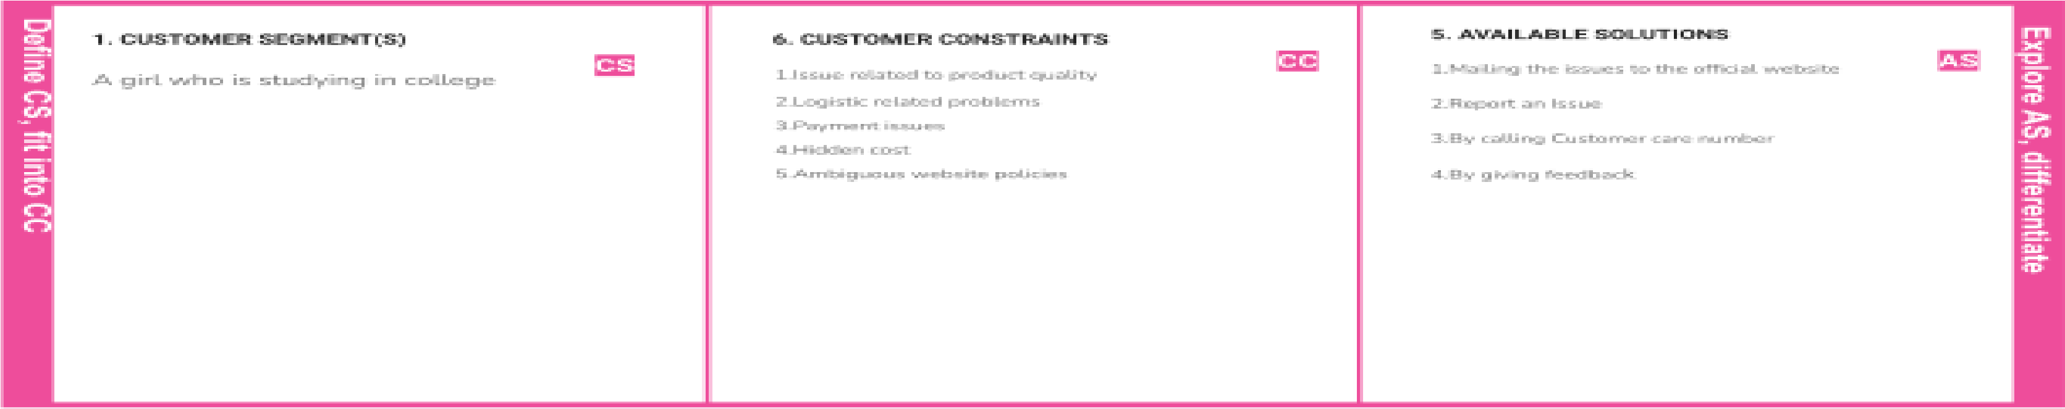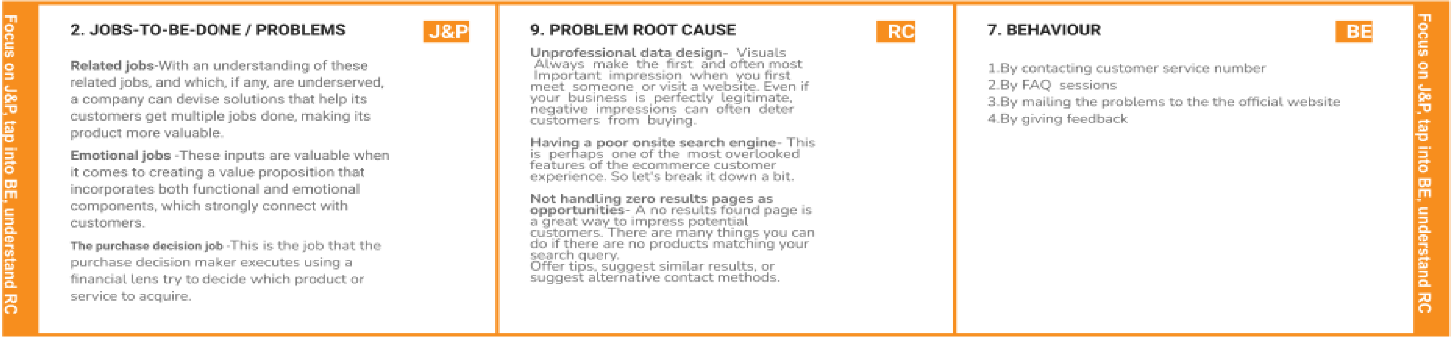

|  |  |  |  |  |
| --- | --- | --- | --- | --- |
|  | 4. EMOTIONS: BEFORE / AFTER EM  If the customer face a problem the customer should get anger but if they are fixed it could |  |  |  |